**ASSIGNMENT 2 FRONT SHEET**

|  |  |  |  |
| --- | --- | --- | --- |
| **Qualification** | **BTEC Level 5 HND Diploma in Computing** | | |
| **Unit number and title** | 10: Website Design & Development | | |
| **Submission date** | 04/01/2021 | **Date Received 1st submission** |  |
| **Re-submission Date** |  | **Date Received 2nd submission** |  |
| **Student Name** | Pham Cao Nguyen | **Student ID** | GCC18074 |
| **Class** | GCC0801 | **Assessor name** | Nguyen Hung Dung |
| **Student declaration**  I certify that the assignment submission is entirely my own work and I fully understand the consequences of plagiarism. I understand that making a false declaration is a form of malpractice. | | | |
|  |  | **Student’s signature** | CaoNguyen |

**Grading grid**

|  |  |  |  |  |  |  |
| --- | --- | --- | --- | --- | --- | --- |
| P5 | P6 | P7 | M4 | M5 | D2 | D3 |
|  |  |  |  |  |  |  |

|  |  |  |
| --- | --- | --- |
| **❒ Summative Feedback: ❒ Resubmission Feedback:** | | |
| **Grade:** | **Assessor Signature:** | **Date:** |
| **Signature & Date:** | | |

**ASSIGNMENT 2 BRIEF**

|  |  |  |  |
| --- | --- | --- | --- |
| **Qualification** | **BTEC Level 5 HND Diploma in Computing** | | |
| **Unit number** | 10: Website Design & Development | | |
| **Assignment title** | Web Services Presentation and Guidebook | | |
| **Academic Year** | 2018 – 2019 | | |
| **Unit Tutor** |  | | |
| **Issue date** |  | **Submission date** |  |
| **IV name and date** |  | | |

|  |
| --- |
| **Submission Format:** |
| *Format:*   1. A report document including some sections  * Section 1: A review of appreciate web design principles, standards and guidelines. * Section 2: Design document for online shopping website. * Section 3: Implementation of website design. * Section 4: Test plan and test evaluation.  1. A compressed file that encapsulates all source code and particular necessary resources including files of images, style sheets, java script and other files to support to install multipage website such as sql script and installation guide.   *Submission* Students are compulsory to submit the assignment in due date and in a way requested by the Tutors. The form of submission will be a soft copy posted on <http://cms.greenwich.edu.vn/>  *Note:* The Assignment *must* be your own work, and not copied by or from another student or from  books etc. If you use ideas, quotes or data (such as diagrams) from books, journals or other sources, you must reference your sources, using the Harvard style. Make sure that you know how to reference properly, and that understand the guidelines on plagiarism. *If you do not, you definitely get failed* |
| **Unit Learning Outcomes:** |
| **LO3** Utilise website technologies, tools and techniques with good design principles to create a multipage website.  **LO4** Create and use a Test Plan to review the performance and design of a multipage website. |
| **Assignment Brief and Guidance:** |
| You work as a full-stack web team leader for a leading creative web solutions and marketing company. Your team is about to have a big contract to develop an online shopping mall.  In order to finish your work effectively you need to review all appropriate principles, standards and guidelines for website designing and development, evaluate all technical challenges to produce a good design document for the online shopping website with wireframes, functional illustrations and a full set of client and user requirements. Then, you lead your team to utilize web design and development technologies, tools and techniques to implement your web design to develop the online shopping website. To get good result, you always ask your team for following your design document by comparison between created multipage website with your design document and evaluation.  As your role, to ensure that the multipage website for online shopping developed by your team is a high quality product, you also need to ask your team members to follow quality assurance process and implement it during your design and development stages by creating a suitable test plan. The test phase should be seriously implemented by reviewing and analysing all test results to evaluate applied quality assurance process and point out suggestions of improvements for online shopping website |

|  |  |  |  |
| --- | --- | --- | --- |
| Learning Outcomes and Assessment Criteria | | | |
| Pass | | Merit | Distinction |
| **LO3** Utilise website technologies, tools and techniques with good design principles to create a multipage website | | | **D2** Critically evaluate the design and development process against your design document and analyse any technical challenges. |
| **P5** Create a design document for a branded, multipage website supported with medium fidelity wireframes and a full set of client and user requirements.  **P6** Use your design document with appropriate principles, standards and guidelines to produce a branded, multipage website supported with realistic content. | | **M4** Compare and contrast the multipage website created to the design document. |
| **LO4** Create and use a Test Plan to review the performance and design of a multipage website | | | **D3** Critically evaluate the results of your Test Plan and include a review of the overall success of your multipage website; use this evaluation to explain any areas of success and provide justified  recommendations for areas that require improvement. |
| **P7** Create a suitable Test Plan identifying key performance areas and use it to review the functionality and performance of your website. User Experience (UX) and User Interface (UI). | **M5** Evaluate the Quality Assurance (QA) process and review how it was implemented during your design and development stages. | |

Contents

Create a design document for a branded, multipage website supported with medium fidelity wireframes and a full set of client and user requirements. 7

**I.** **Create design document.** 7

**1.** **Project Specification:** 7

**2.** **Client:** 7

**3.** **Data are given by the customer:** 7

**4.** **Scope of the Work:** 7

**5.** **Customer Acceptance Criteria:** 8

Use your design document with appropriate principles, standards and guidelines to produce a branded, multipage website supported with realistic content. 11

**I.** **Functional of multipage website:** 11

✓ **Home page:** 11

✓ **Register page:** 11

✓ **Login page:** 13

✓ **Update registered members.** 14

✓ **Administrator section.** 14

**II.** **The “Management” is “product management”.** 15

✓ **Product Management “Add new”.** 15

✓ **Update Product** 16

✓ **Delete product** 17

**III.** **The “Management” is “Product category".** 17

✓ **Product category “Add”.** 18

✓ **Edit Category of product** 18

✓ **Delete Category of product** 19

Create a suitable Test Plan identifying key performance areas and use it to review the functionality and performance of your website. User Experience (UX) and User Interface (UI). 19

APENDIX: https://drive.google.com/drive/folders/1k1pdbJJdfvSnPTAVszuRurlvAydcvORy?usp=sharing 23

References 24

# Create a design document for a branded, multipage website supported with medium fidelity wireframes and a full set of client and user requirements.

1. **Create design document.**
2. **Project Specification:**

* IFS.com is an online store for various types of Fruit. They have collection of Fruit. Now they want to revamp their website with all the products listed on the website. Consumers should find it easy to view various products and decide upon purchasing the right product to meet their requirements.
* A website needs to be designed to display various fruit available with the store. Details of locations, feedback must be included.
* The website is to be developed for the Windows Platform using HTML5, CSS, JavaScript and PHP. The site should work well in all leading browsers including Chrome, IE, Firefox etc.

1. **Client:**

* IFS Store

1. **Data are given by the customer:**

* Input data to the system:
* Information about products categories: **Category ID, Category Name,** Description.
* Information about products: Product ID, Product Name, Price, Quantity, **Image of product.**
* Information of customer: Username, Password, Full name, Email, Address, Telephone, Gender and Date of Birth.
* Output data from the system:
* List fruit Category.
* List all fruit and fruit detail.
* Process involved in the system:
* Processing customer’s registration.
* Processing customer’s login.
* Adding, updating, deleting fruit category.
* Adding, updating, deleting fruit.

1. **Scope of the Work:**

* Plan a website for online shopping with product categories.
* When the user is registered with the site and can be logged in to the site.
* Customers can send feedback to the shop directly via email and phone number.
* Perform the following functions for administrators:
* Add, edit, and delete product.
* Add, edit, and delete category.

1. **Customer Acceptance Criteria:**

|  |  |
| --- | --- |
| **No.** | **Criteria for Consumer acceptance** |
| 1. | The home page should be created by a suitable logo, the header should be created by button contain links to customer directional they want. |
| 2. | The user can register members of the store and then can log in to the website. |
| 3. | Product name and product price must be added with the images. |
| 4. | Customer can register member of store and then can login the website |
| 5. | Links of the product must be categorized like: (fruit, gift baskets...) |
| 6. | Administrators may perform the function as add, edit, and delete products. |
| 7. | Administrators may perform the function as add, edit, and delete category. |

1. **Architecture of the Application.**

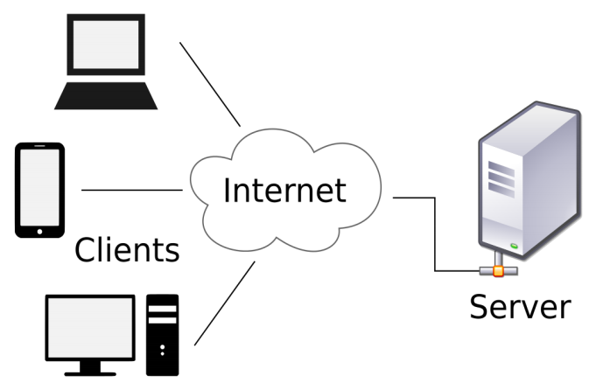

1. **Data Flow Diagram.**



**LEVEL 0 DFD**

1. **Use case diagram.**

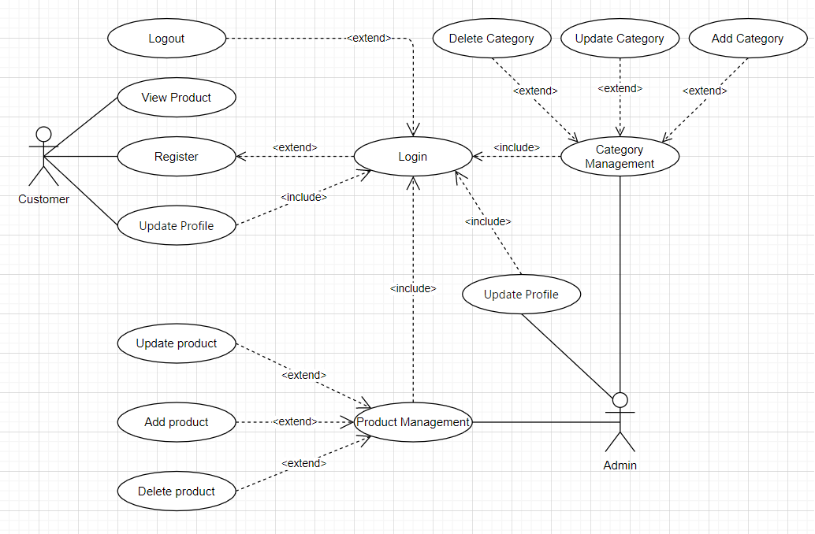

1. **Database diagram.**

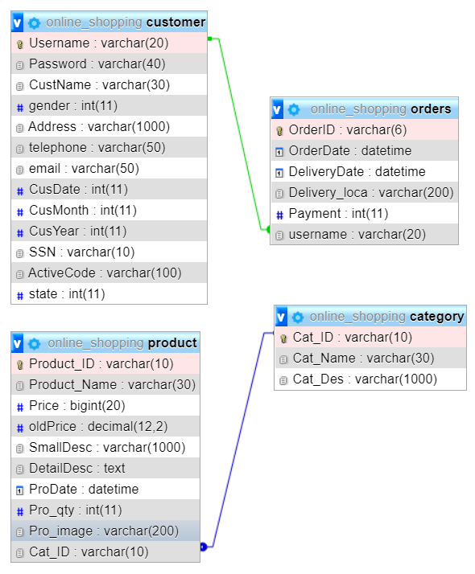

1. **Site map.**

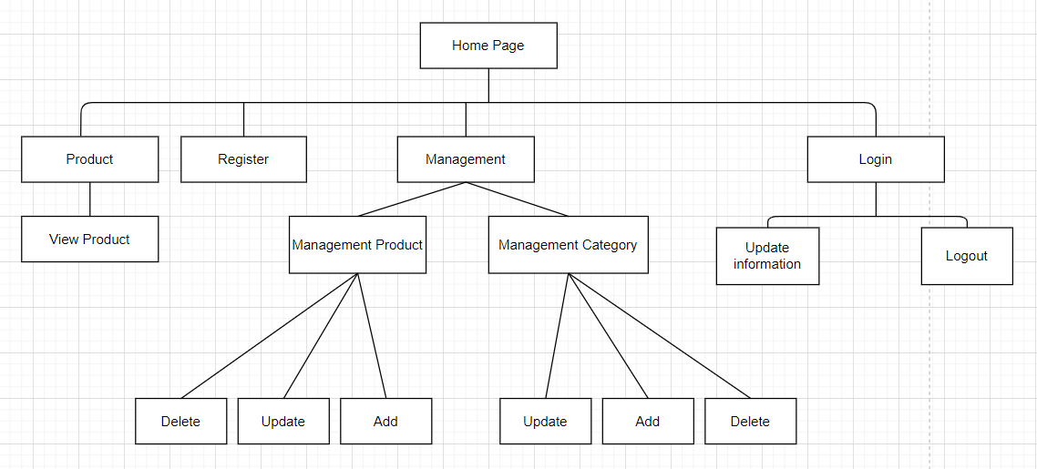

1. **Wireframes and specific explanation.**

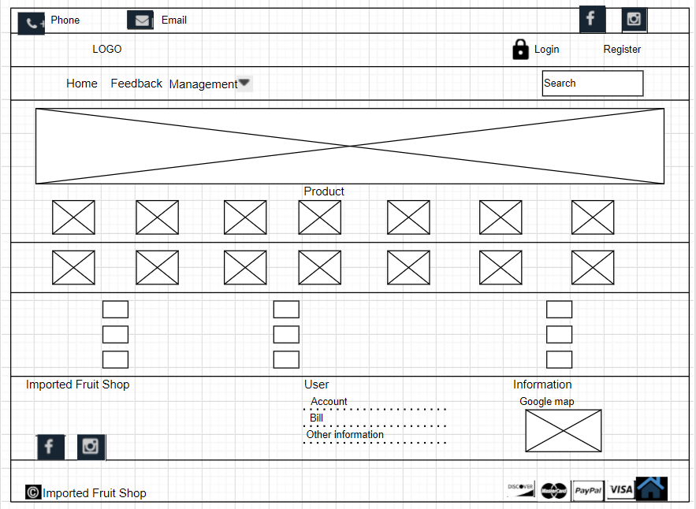

Based on request IFS.com, they need inappropriately with the log. The navigation section should be appropriately designed for the customer can see easily. Images will show different types of products of the store as fruit, fruit basket, etc. When the customers access the site they will see the introduction of products through forms showing on the site. From that, the customers may see the type of news and ad products. When the customers were seen and want to buy it then they could be service reference at down there include free shipping worldwide, free return, and 24h fast support. Footer will show the logo of the store and many Facebook, Instagram contacts, and google map**.**

# Use your design document with appropriate principles, standards and guidelines to produce a branded, multipage website supported with realistic content.

1. **Functional of multipage website:**

* **Home page:**
* Users and admin can login here, users can view products and register their accounts and update information, but administrators can perform the function as add, edit, and delete products, and may perform the function as add, edit, and delete category.

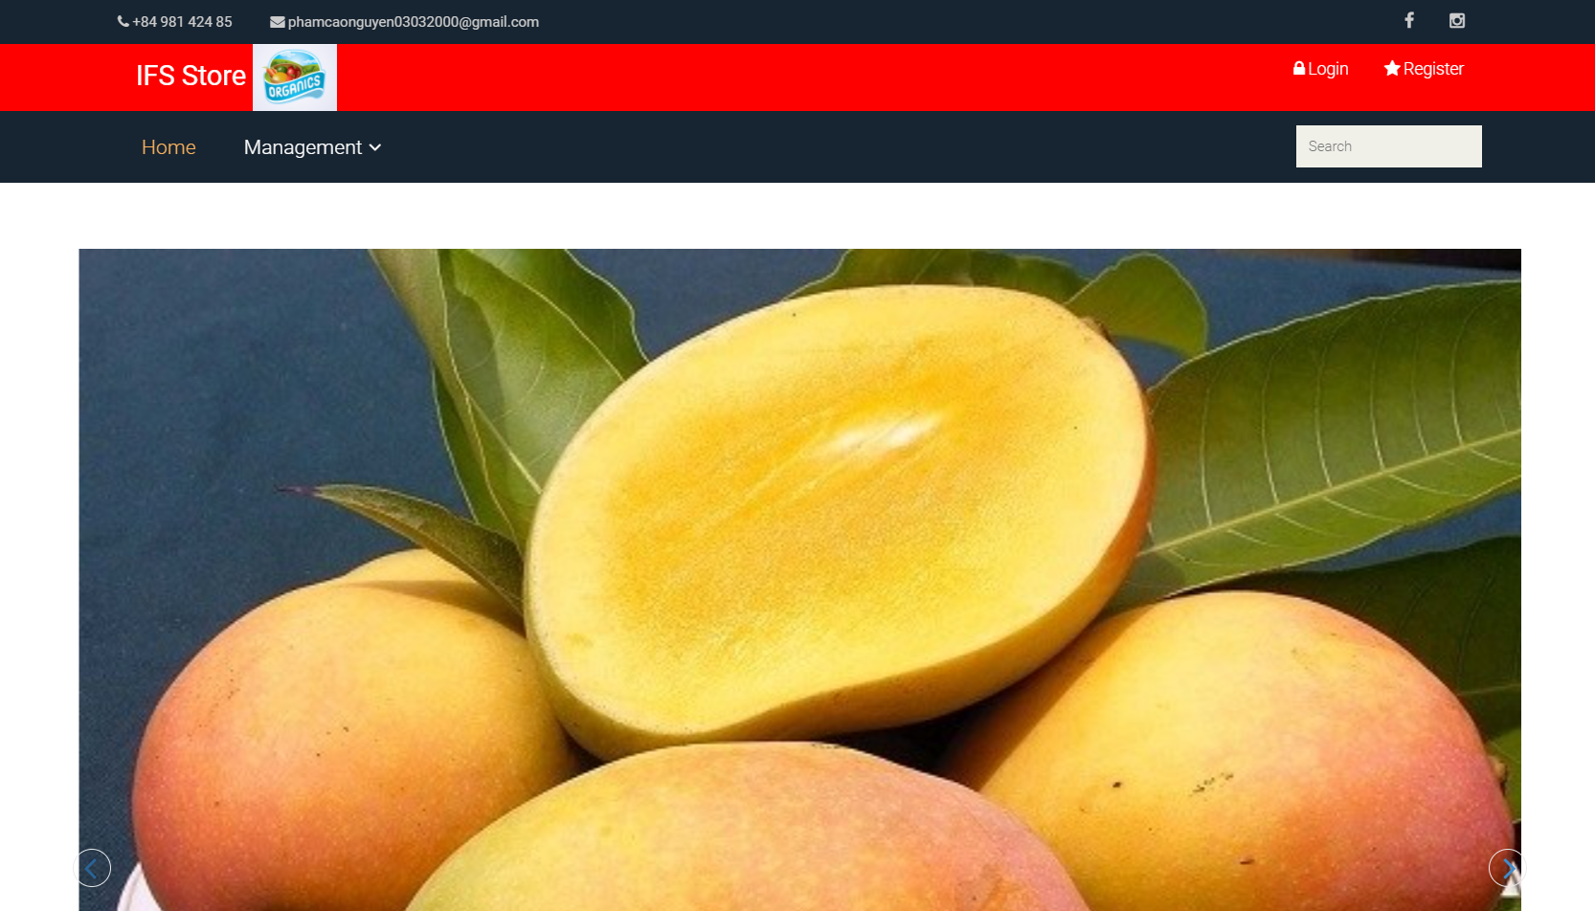

* **Register page:**
* The administrator will also register with the register page, the user can register with the site, but can’t log in with administration cause administration just to build on the database. On the database have “state” column with a state equal to “0” is for the normal user account and a state equal to “1” is for an administrator account.

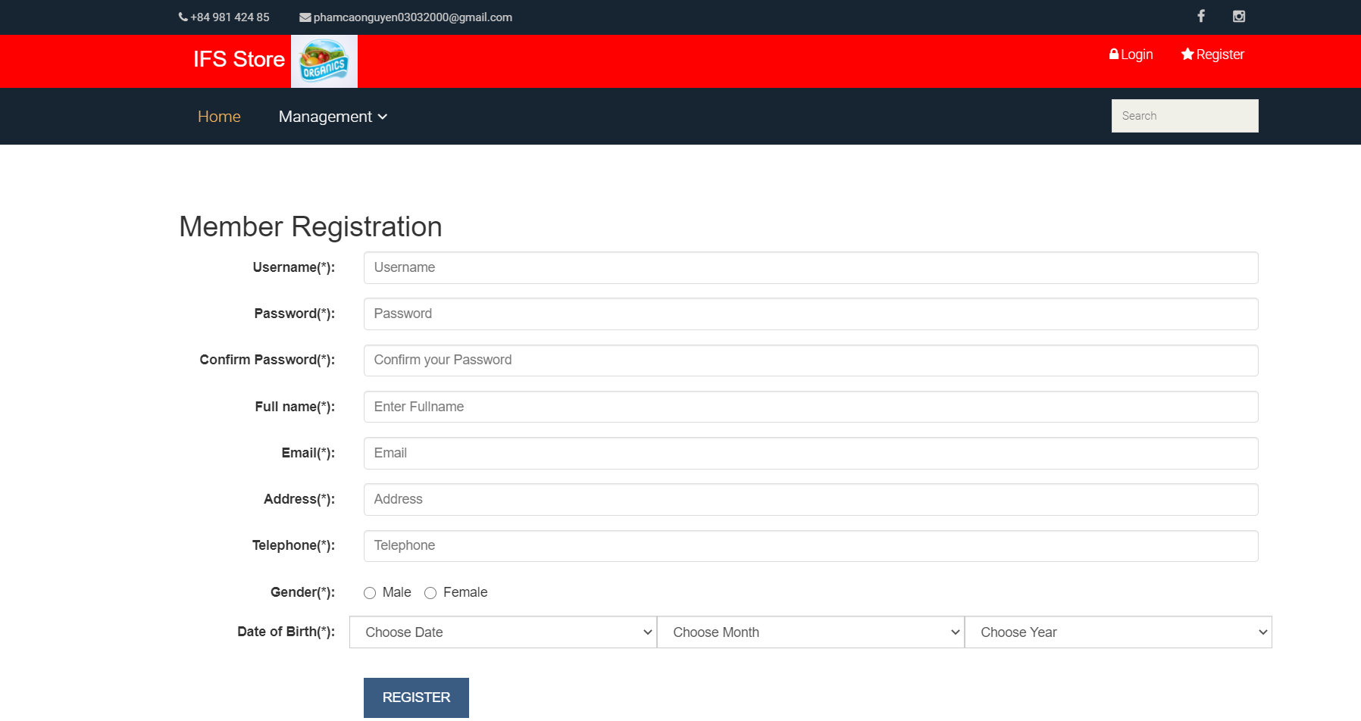

* In this register form, the user must do input all personal information including Username, Password, Confirm Password, Full name, Address, Email, Telephone, Gender, and Date of birth.
* When user input not enough one of the requests then the system will be sent the notification on the screen report they know the information not enough or password not match.
* Enter fields with mark:

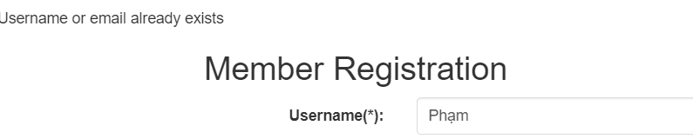

* Password must be greater than 5 chars:

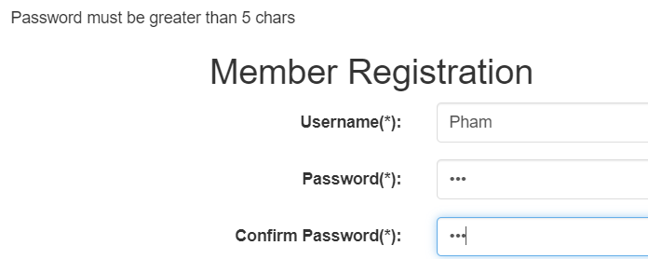

* The password and the confirmation password are not the same:

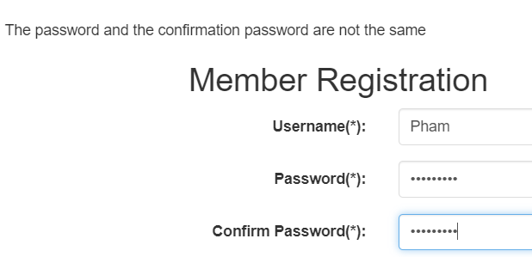

* Choose Year of Birth, please:

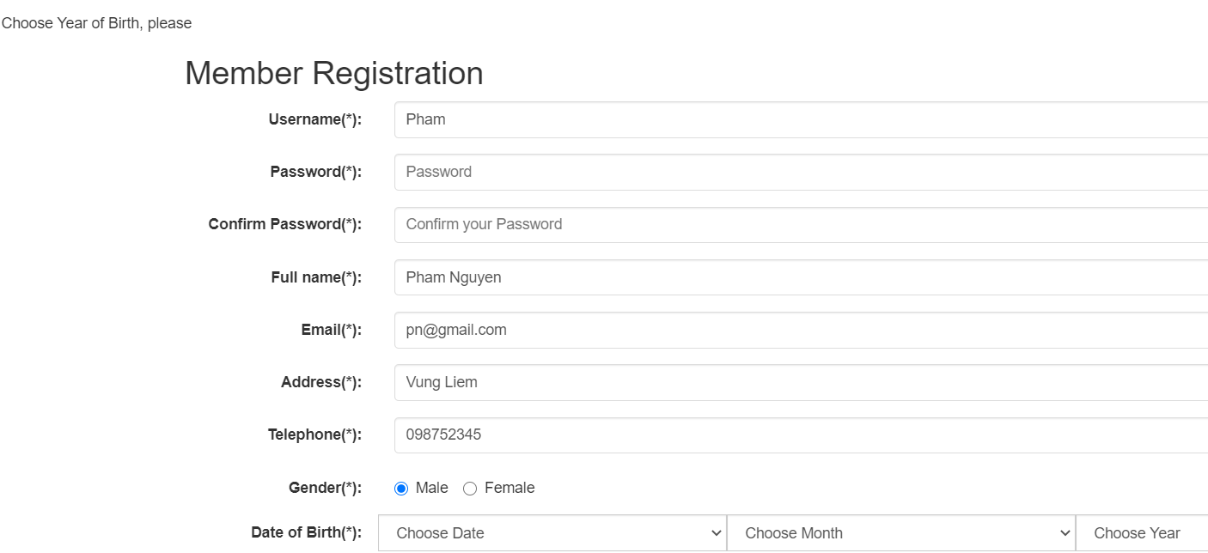

* **Login page:**

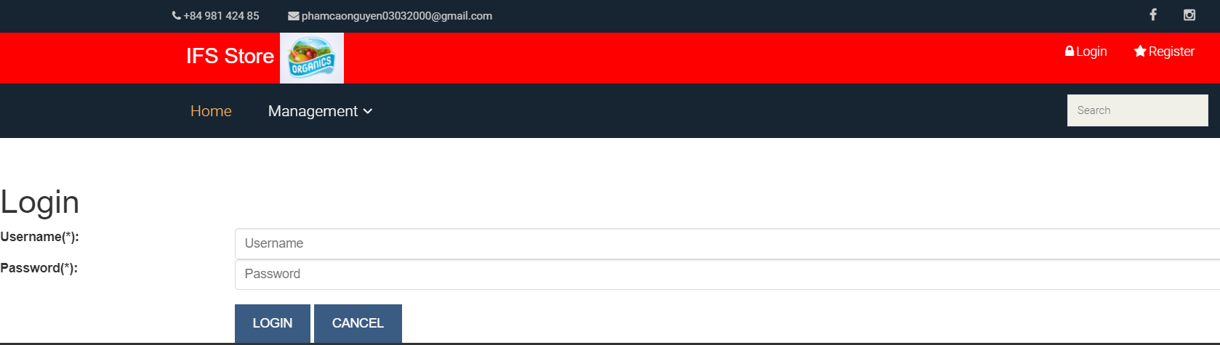

* The login page created for the purpose of accessing the web for both visitors and administrators accesses the site carry out the necessary issues.

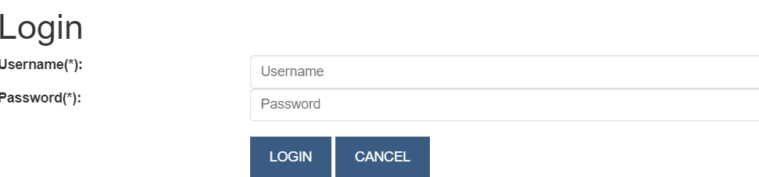

* What login functionality users and administrators should know all the statuses on the screen by warning display whether they signed in failed to trigger input, inadequate username or password. If they log in with the correct password and username then from login page load to home page.
* If the user or administrator is logged in incorrectly.

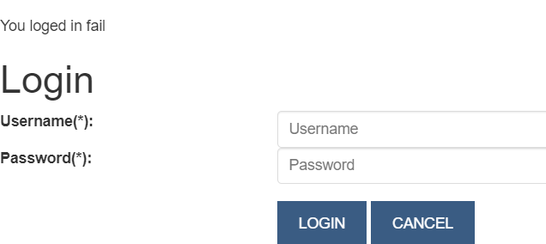

* **Update registered members.**
* When the user login with the username “nguyen” is complete, at that time, register feature will be modified with “Hi, nguyen” showing personal details on the page.
* “Hi, nguyen” has to display when the user has successfully logged in. In Hi, “nguyen” includes “Hi”, which is formatted by the system, and when logged in, “nguyen” is the username.



* User and administrator can be edit personal profiles when they want. But the user and administrator does not edit username, email and state.

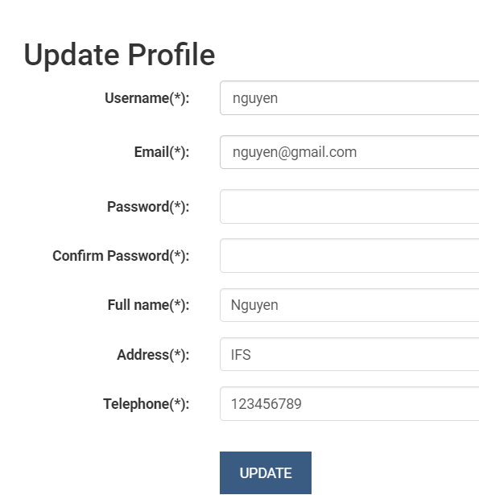

* **Administrator section.**
* When the administrator login to the website, “management” including “category” and “product” will be accessible.

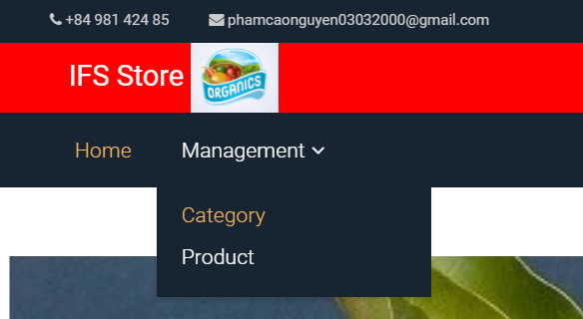

1. **The “Management” is “product management”.**

* In that here, the administrator could be seen all information include No., Product ID, Product Name, Price Quantity Category ID, Image and function edit and delete.

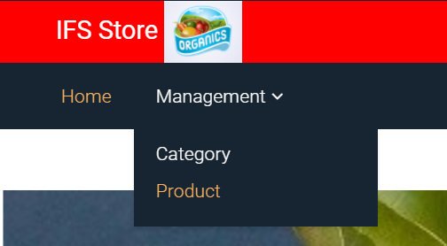

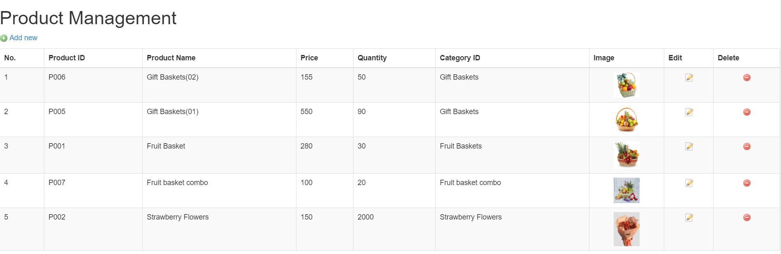

* **Product Management “Add new”.**
* The administrator wants to add new a product then they access the “Add Product”. It showed table with many information include Product ID, Product Name, Product Category, Price, Short description, Detail description, Quantity, and Image.

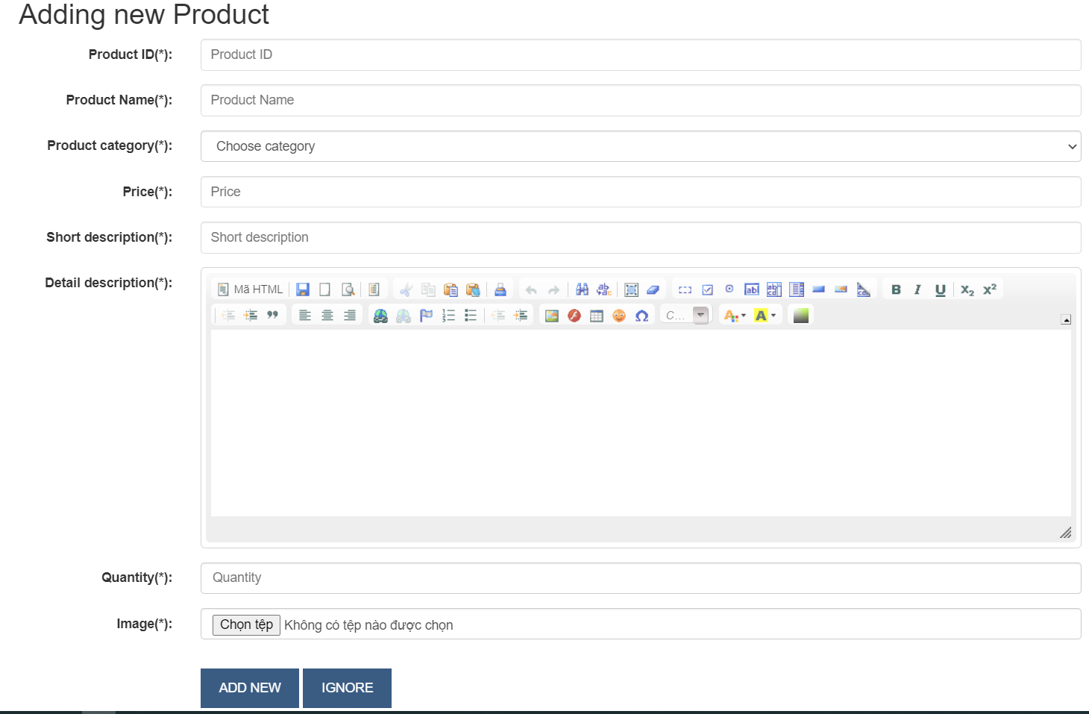

* When the administrator clicks on update, the system will notify add new successfully.

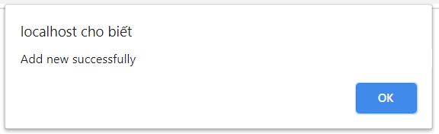

* They must be add all the information if they does not enough then the system will sent notification on the screen.
* For example:

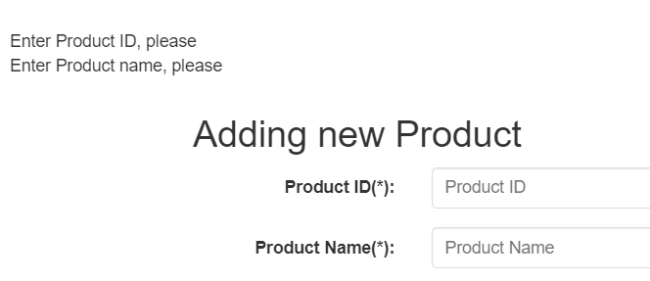

* **Update Product**
* When the administrator needs to edit product information, at row edit, they just click on the item function. Except that the product ID does not change, they will change all product details.

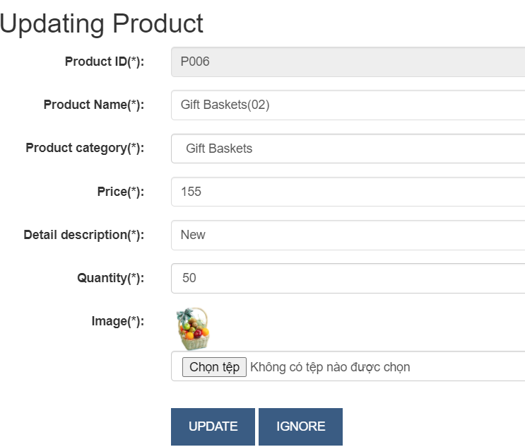

* **Delete product**
* If an administrator needs to delete a product, they only click on the delete row item function. When they click on delete function the system well notification to confirm they want to delete a product specified.

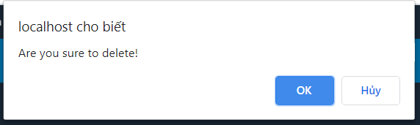

1. **The “Management” is “Product category".**

* In that here, the administrator could be seen all information include No., Category Name, Description, and more two function are edit and delete function.



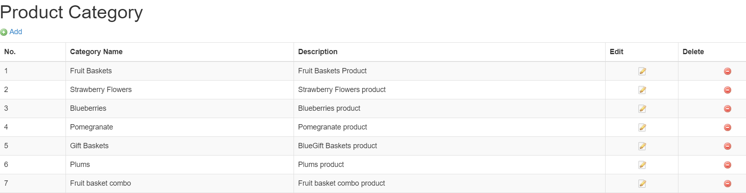

* **Product category “Add”.**
* The administrator wants to add new a product then they access the “Add_Category”. It showed table with many information include Category ID, Category Name, Description, and click “ADD NEW”.

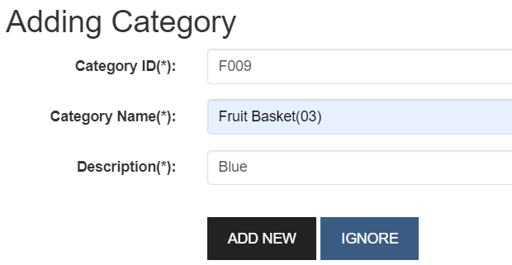

* They must be add all the information if they does not enough then the system will sent notification on the screen.
* For example:

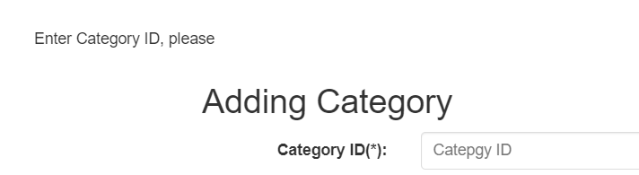

* **Edit Category of product**
* When the administrator wants to edit category information of the product, they just click the item function at row edit. They can change all category information of the product category information of the product except the Category ID does not change.

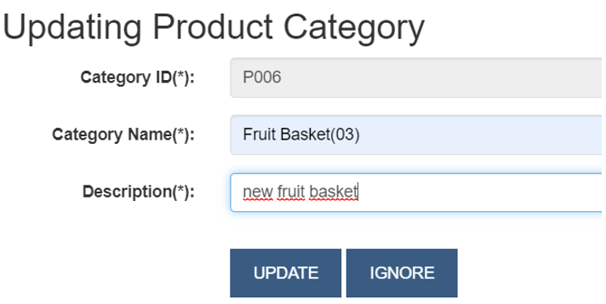

* **Delete Category of product**

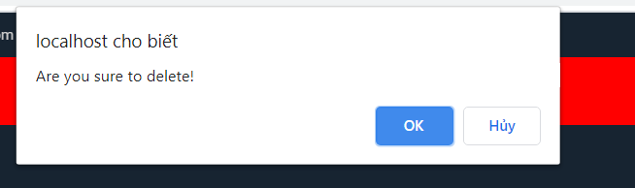

* When an administrator wants to delete a category of product, they just click the item function “” at row delete. When they click on delete function the system sent notification to confirm they want to delete a category of the product specified.

# Create a suitable Test Plan identifying key performance areas and use it to review the functionality and performance of your website. User Experience (UX) and User Interface (UI).

|  |  |  |  |  |  |  |
| --- | --- | --- | --- | --- | --- | --- |
| **No.** | **Test case** | **Function** | **Input Data** | **Expected output** | **Actual output** | **Evaluation** |
| **1.** | Verify that “You have registered successfully” message is displayed when user enters valid information | Register | Input valid information into form “Username: nguyen, Password: 123456789,  Full name: Nguyen, Address: IFS, Telephone: 123456789, Gender: Male, Date of Birth: 3/3/2000” | “You have registered successfully” message is displayed | “You have registered successfully” message is displayed | Pass |
| **2.** | Verify that the registration of personal information is unsuccessful | Register | Input valid information into form “Username: nguyen, Password: 123456789, Full name: Pham Cao Nguyen, Email: nguyen@gmail.com, Address: Vinh Long, Telephone: 12345678909, Gender: Male, Date of Birth: 1/1/2001” | “Username or email already exists!” Please enter another name (email)! message is displayed | “Username or email already exists!” Please enter another name (email)! message is displayed | Pass |
| **3.** | Verify that Home page and “Hi, nguyen” are displayed when user enters valid username and password | Log in | Username: nguyen  Password: 123456789 | Home page and “Hi, nguyen” are displayed | Home page and “Hi, nguyen” are displayed | Pass |
| **4.** | Verify that “You logged in fail” massage is displayed when user enters invalid username or password | Log in | Username: nguyen  Password: 123456 | “You logged in fail” massage is displayed | “You logged in fail” massage is displayed | Pass |
| **5.** | Verify that the product information generated on the Category management page was successful. | Add Category | Category ID: H100  Category Name: Fruit Basket (09)  Description: Fruit Basket (09) includes cherry, banana, apple, and mango, ... | “Add Product category successfully” message is displayed | Successfully added Product Category “H100” but there are no messages is displayed. | Fail |
| **6.** | Verify that the product info created on the Category Manager page failed | Add Category | Category ID: H100  Category Name: Fruit Basket (09)  Description: Fruit Basket (09) includes cherry, banana, apple, and mango, ... | “Duplicate category ID or Name” message is displayed | “Duplicate category ID or Name” message is displayed | Pass |
| **7.** | Verify that the Category product information is updated on the successful Category management page. | Update Category | Category ID: H100  Category Name: Fruit Basket (08)  Description: Fruit Basket (08) includes cherry, banana, apple, and mango, ... | “Update Product category successfully” message is displayed  page | Successfully update Product Category “H100” but there are no messages is displayed. | Fail |
| **8.** | Verify that the Category product information is updated on the unsuccessful Category management page. | Update Category | Category ID: H100  Category Name: Fruit Baskets  Description: Fruit Basket (08) includes cherry, banana, apple, and mango, ... | “Duplicate category Name” message is displayed on page | “Duplicate category Name” message is displayed on page | Pass |
| **9.** | Verify that the Category product information is deleted on the successful Category management page. | Delete Category | Click the delete button | Show the confirm dialog “Are you sure to delete”. | Show the confirm dialog “Are you sure to delete”. | Pass |
| **10.** | Verify that the product information generated on the Product management page was successful. | Add Product | Product ID: N100,  Product Name: Gift Baskets (09),  Product category: Gift Baskets,  Price: 268,  Detail description: Gift Basket New,  Quantity: 50 | “Add new successfully” message is displayed | “Add new successfully” message is displayed | Pass |
| **11.** | Verify that the product information created on the Product Management page failed. | Add Product | Product ID: N100,  Product Name: Fruit Basket combo,  Product category: Fruit Basket combo,  Price: 260,  Detail description: New Combo,  Quantity: 50 | "Duplicate product ID or Name” message is displayed | "Duplicate product ID or Name” message is displayed | Pass |
| **12.** | Verify that the product information is updated on the successful Product management page. | Update Product | Product ID: N100,  Product Name: Gift Baskets (08),  Product category: Gift Baskets,  Price: 268,  Detail description: Gift Basket New,  Quantity: 50 | “Update Product successfully” message is displayed  page | Successfully update Product management “N100” but there are no messages is displayed. | Fail |
| **13.** | Verify that the product information is updated on the unsuccessful Product management page. | Update Product | Product ID: N100,  Product Name: Gift Baskets (02),  Product category: Gift Baskets,  Price: 268,  Detail description: Gift Basket New,  Quantity: 50 | “Duplicate product Name” message is displayed  page | “Duplicate product Name” message is displayed  page | Pass |
| **14.** | Verify that the product information is deleted on the successful Product management page. | Delete Product | Click the delete button | Show the confirm dialog “Are you sure to delete”. | Show the confirm dialog “Are you sure to delete”. | Pass |

# APENDIX: <https://drive.google.com/drive/folders/1k1pdbJJdfvSnPTAVszuRurlvAydcvORy?usp=sharing>

Admin:

Username (*): nguyen

Password (*): 123456789

Customer:

Username (*): cao

Password (*): 123456789

# References

Robbins, J.N., 2012. *Learning web design: A beginner's guide to HTML, CSS, JavaScript, and web graphics*. " O'Reilly Media, Inc.".

Niederst, J. and Robbins, J.N., 2003. *Learning Web design: a beginner's guide to HTML, graphics, and beyond*. " O'Reilly Media, Inc.".

Shenoy, A. and Sossou, U., 2014. *Learning Bootstrap*. Packt Publishing Ltd.